Lab #1

Tolerance Assigning, Machining and testing of a two-part Assembly

Class: ENGR 3350-001

Lab Section: 202

Time/Day: TR 2:00-3:15

Authors: Hannah Bishop, Justis Findley, and Ethan Zickert

Team:7

Start Date: September 9th, 2025

End Date: September 25th, 2025

**Abstract**:

The purpose of this lab is to manufacture a two-piece assembly. The assembly consists of two parts: a plate and a rod, which were made from 6061-T6 Aluminum. This was to practice collecting accurate measurements, cutting, machining, tapping, and assembling skills. A second goal for this lab was for us students to get hands-on experience using different machinery equipment. This enabled students to work with various machines and different hand tools to understand and practice the processes needed to make parts.

**Introduction:**

The goal of this lab was to machine two different parts, the two parts were a flat plate and then a shaft, to tolerances and then press fit the shaft into the center hole of the flat plate, this created our desired assembly. The recommended tolerances were +.003 inches to +.005 inches; these were recommended to achieve maximum efficiency. The interference fit was necessary to prevent any rotation or other deformation of the shaft or plate when under load. The two-part assembly would have been tested by hanging weight on the notch of the shaft to demonstrate its ability to handle torque load. It was necessary for both the shaft and the center hole of the plate to have small tolerances due to the shaft being press fit into the plate. If the shaft was too large and it's attempted to press fit, it would have caused a deformation of the plate and shaft. Also, if the shaft diameter was too small, the fit between the shaft and the plate would have been too loose to support the necessary torque load. All interference values were specified by the lab instructor. The material used for this lab was Aluminum, it was the best choice due to it being inexpensive, which leaves room for students, who are new to machining to make errors without there being a big cost. It's also a material that is known to be easy to machine.

**Theory**:

The illustrations in Figures 1-3 show the sketched dimensions, then crossed out with measured/calculated values. Figure 1 shows the dimensions of the aluminum shaft, and Figure 2 shows the dimensions of the aluminum plate. The completed assembly is shown in Figure 4, where the aluminum shaft is pressed into the plate. To ensure proper fitment, the process would be taken carefully and slowly. To achieve a proper interference fit, a max of +0.005 inches will be added to the shaft compared to the center hole in the plate. Both the shaft and plate were received with rough cuts to allow them to be machined down with more accuracy. When drilling the holes in the plate, a center drill is required to locate the position, as well as to create a pilot hole so that the drill bit does not walk. For the center hole, the dwelling method is used along with a vacuum to remove any chips. The equation used to calculate the contact pressure is shown in Equation 1and this equation is used to determine the interference of the assembly. Since both materials are Aluminum, a Poisson ratio of 0.3 is used, and the modulus of elasticity is 10 x 10^6 psi.

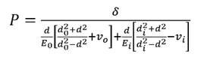

(Equation 1)

Where:

P = pressure (psi)

E = Modulus of Elasticity (psi)

d = Interference (inches)

v = Poisson’s Ratio

d = Diameter of Plate Center Hole (0.75 inches)

do = Diameter of Outer Part (2.25 inches)

di = Diameter of Hollow Shaft (0)

Subscripts:

o = Outer Material

i = Inner Material

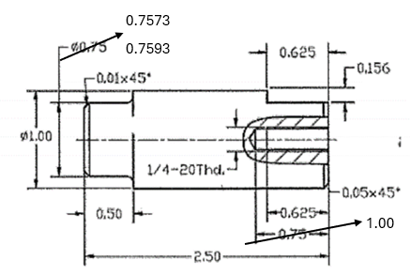

**Figure 1:** Dimensions of the Aluminum shaft

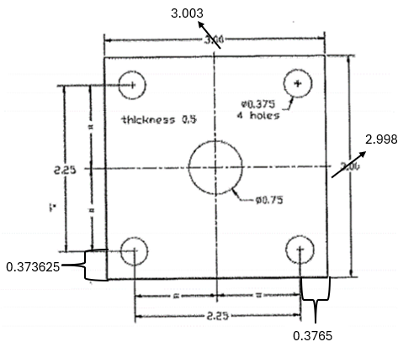 **Figure 2:** Dimensions of the Aluminum plate

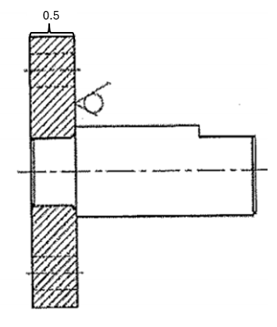

**Figure 3:** Assembly side view

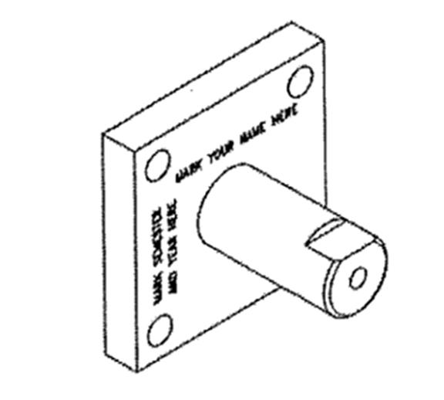

**Figure 4:** Final assembly isometric view

**Equipment:**

Primary Equipment:

* Lathe

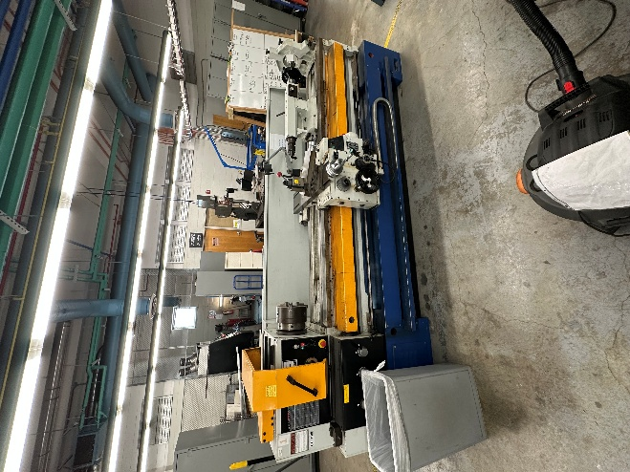

Figure 5: Front view of Lathe

* GH-1640ZX Lathe

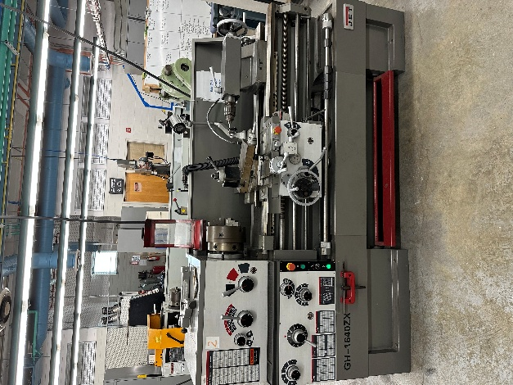

Figure 6: Front view of GH-1640ZX Lathe

* Bridgeport Milling Machine

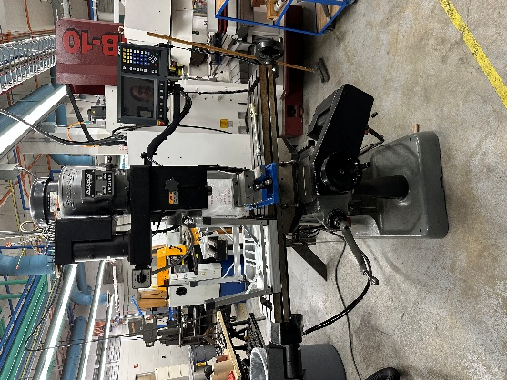

Figure 7: Front view of Bridgeport Milling Machine

* AGER E-mill Milling Machine

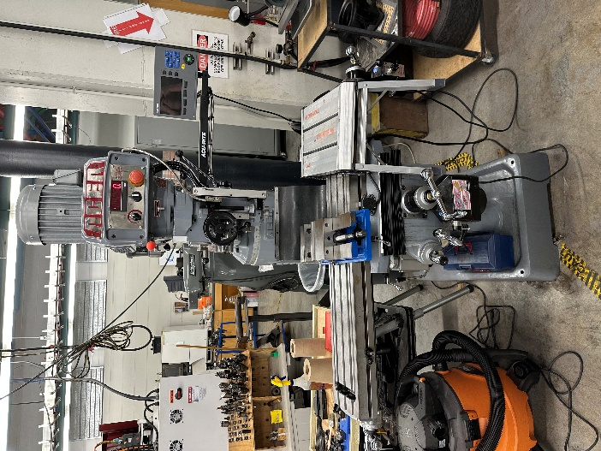

Figure 8: Front view of AGER E-mill Milling Machine

* Hydraulic Shop Press

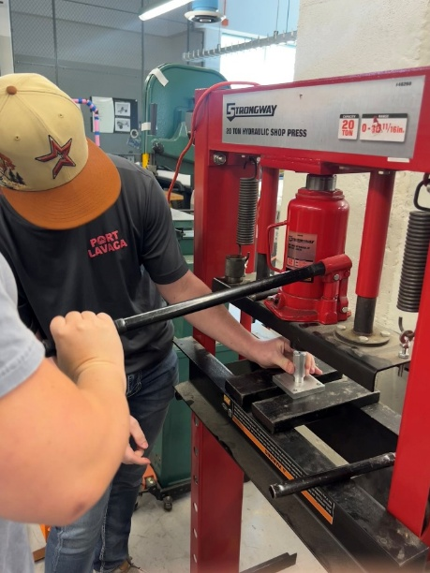

Figure 9: Front view of Hydraulic Shop Press

Auxiliary Equipment:

* Tap set

- Taper Tap

- Plug Tap

- Bottom Tap

* Dial Caliper
* Feeler Gauge
* File
* Shop Vacuum
* End Mill
* Ink Spray
* Paint Brush
* 3/8-inch Drill Bit
* #7 Drill Bit
* Lubricating oil
* Parallel Bars
* Hammer
* Character Punch Kit

Safety Equipment:

* Safety Glasses
* Hair Ties

**Procedure:**

**Aluminum Plate Machining:**

1. An Aluminum 6061-T6 flat plate was measured on all sides with a caliper to start the process. Two sides were manufactured and estimated to be 3.003 inches, within the tolerance given ± 0.005 inch.
2. Setting parallel bars to make the plate lie flat, then clamping it with a vice.

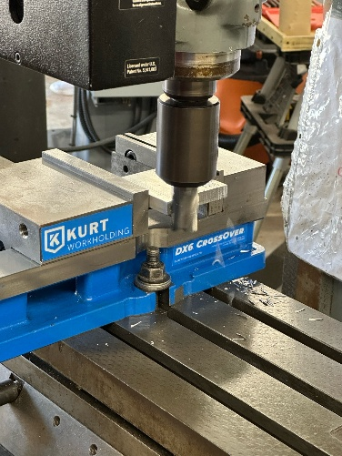

Figure *10 Milling of plate side 1*

1. Turn on the mill, then cut just enough of the plate to make the side even. Use a file to ensure no sharp edges and to smooth the sides.

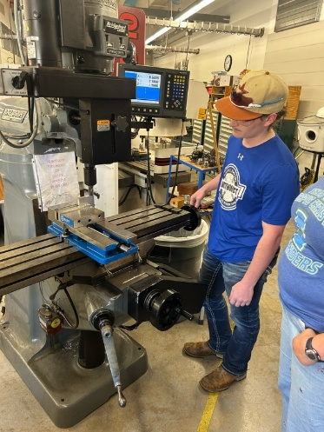

Figure 11 *Filing sides of the plate*

1. The plate was measured using a caliper to determine how much we needed to remove to reach the required length.
2. The parallel bars were removed, and the plate was rotated vertically.

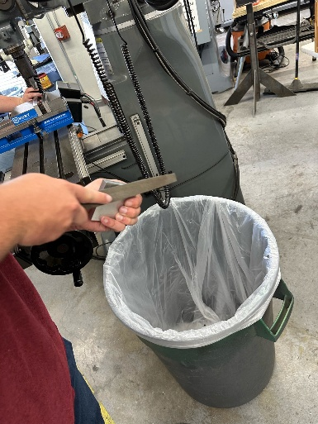

Figure 12: *Milling the length of the plate down*

1. The milling machine was used to mill off 0.003 inch until the plate reached the length of 2.998 inches, which was within the tolerance of 3.00inch +-0.005inch.
2. The milling machine cut them to about 2.998 inches on one side and 2.9965 inches on the other. The sides of the plate were measured multiple times, and the average of the measurements was taken.
3. Blue spray paint was used to put a very thin layer of paint on the plate to prepare it for scoring.
4. Once the plate was dried, it was labeled with the sides A-D and the corners 1-4.
5. The plate required four 0.0375-inch holes in each corner and a center hole at 0.75 inch. Using the measured values from step 2, subtract 2.25 inches from the measurements and divide them by 2 for the small holes. The center hole was measured to be the center of the plate.
6. An etcher was used to scrape the paint to see where the holes were needed. The etcher was placed flat on the table to be zeroed out.
7. 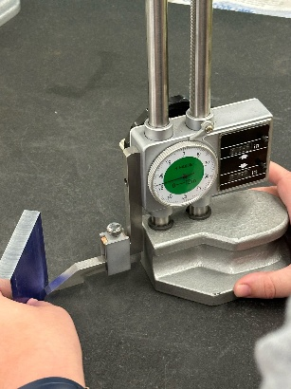Raising the etching dial from the bottom of the table to the proper length to etch. Etched the length needed, then rotated and completed the intersecting points where the holes needed to go.

Figure 13 *etching one of the four holes*

1. The handles on the milling machine must align with the hole marks we etched properly. Use a center bit to start the holes. When lining up, lightly tap the bit down to see a small mark to ensure alignment.

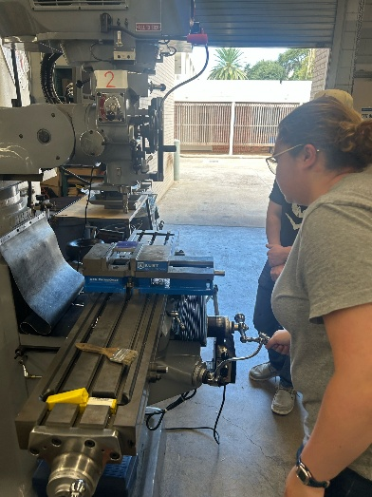

Figure 14: *Using the handles to align the plate with the holes etching cross sections*

1. The center bit starts the hole so the drill bit can be appropriately guided.
2. The seven drill bits were used to drill the four 0.0375-inch holes, and pecking (moving in and out repeatedly) kept chips from affecting the hole. Use a brush to keep the chips from growing on the drill bit.

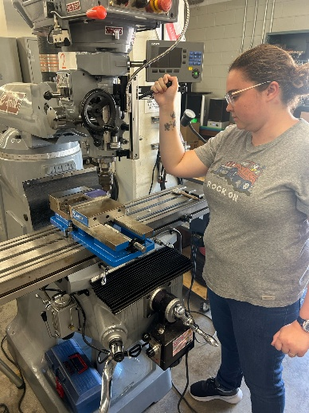

Figure 15: drilling one of the four holes

1. Move on to the center hole, which needed to be 0.75 inches.
2. The center bit was used to properly align the hole but was not used.
3. Change to an R8 Quill bolt for the 0.75 inches hole; this hole will be press-fitted to a shaft.
4. Bringing the bolt down, using the same pecking motion. A shot vac is used to keep no chips in the hole.

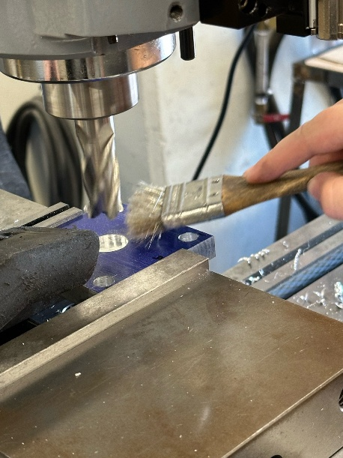

Figure 16: *Drilling the center hole*

1. A small file is used to make the circle's bottom edges smooth.

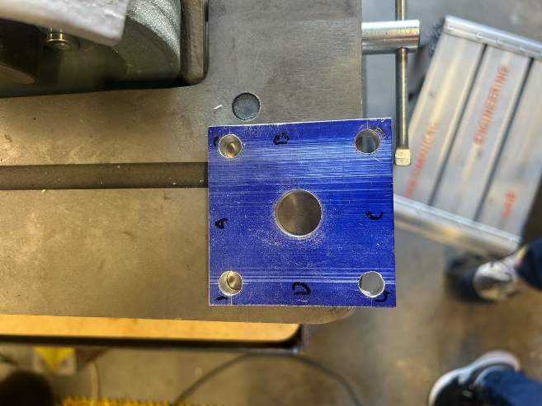

Figure 17 *finished plate*

**Aluminum Shaft Machining:**

1. An Aluminum 6061-T6 round bar was inserted into the three-jaw chuck of the GH-1640ZX Lathe and tightened in place with the T-handle.
2. The cutting tool was butted up to the round stock, then moved away in the +X direction to allow the tool to move in the -Z direction.
3. The Lathe was powered on, and the automatic advance was activated and allowed to cut until the center of the stock.
4. The compound rest was moved out of the way to allow the tailstock to be used.
5. The center bit was installed into the chuck of the tailstock.
6. With the lathe turned on, the center bit was advanced using the quill.
7. Next, the #7 drill bit was marked at a depth of 1-inch and inserted into the quill.
8. With the lathe on, the drill bit was advanced slowly using a pecking motion until it reached the 1-inch mark.
9. The taper tap was inserted into the quill.
10. The lathe was rotated counter clockwise by hand while the quill advanced by hand to ensure the threads started straight.
11. Once the threads were started, the tap was left in the stock and continued by hand using a T-handle.
12. After the tapper tap got to the end of the hole the plug tap was used in the same manner.
13. Then the bottom tap was used to finish the threads.
14. The stock was then removed and the hole was blown out using compressed air.
15. The round stock was flipped around and inserted into the three-jaw chuck with enough room to measure using the calipers.
16. The stock was then machined down in increments of 0.005 inch until the part reached its final length of 2.5000 inches.
17. Once the part was at its final length, we set the tool head at -0.5 inches in the + Z direction compared to the end of the part.
18. Then, with the lathe on, the tool moves in the – X to reduce the diameter of the end of the shaft.
19. The diameter was reduced to 0.005 inches larger than the hole in the plate to ensure proper fitment.
20. Using the file, a chamfer was put on the edges to remove any sharp corners.

**Press Fitting:**

1. Used the Strongway 20 Ton Hydraulic Shop Press to press the shaft into the center hole of the flat plate, and made sure the round bar was perpendicular to the flat plate.
2. Lubrication was sprayed on the round bar.
3. The flat plate sat on a metal plate and compressive cap was placed on the round bar.
4. Went down slowly to ensure the Shaft was going perpendicular into the plate.
5. 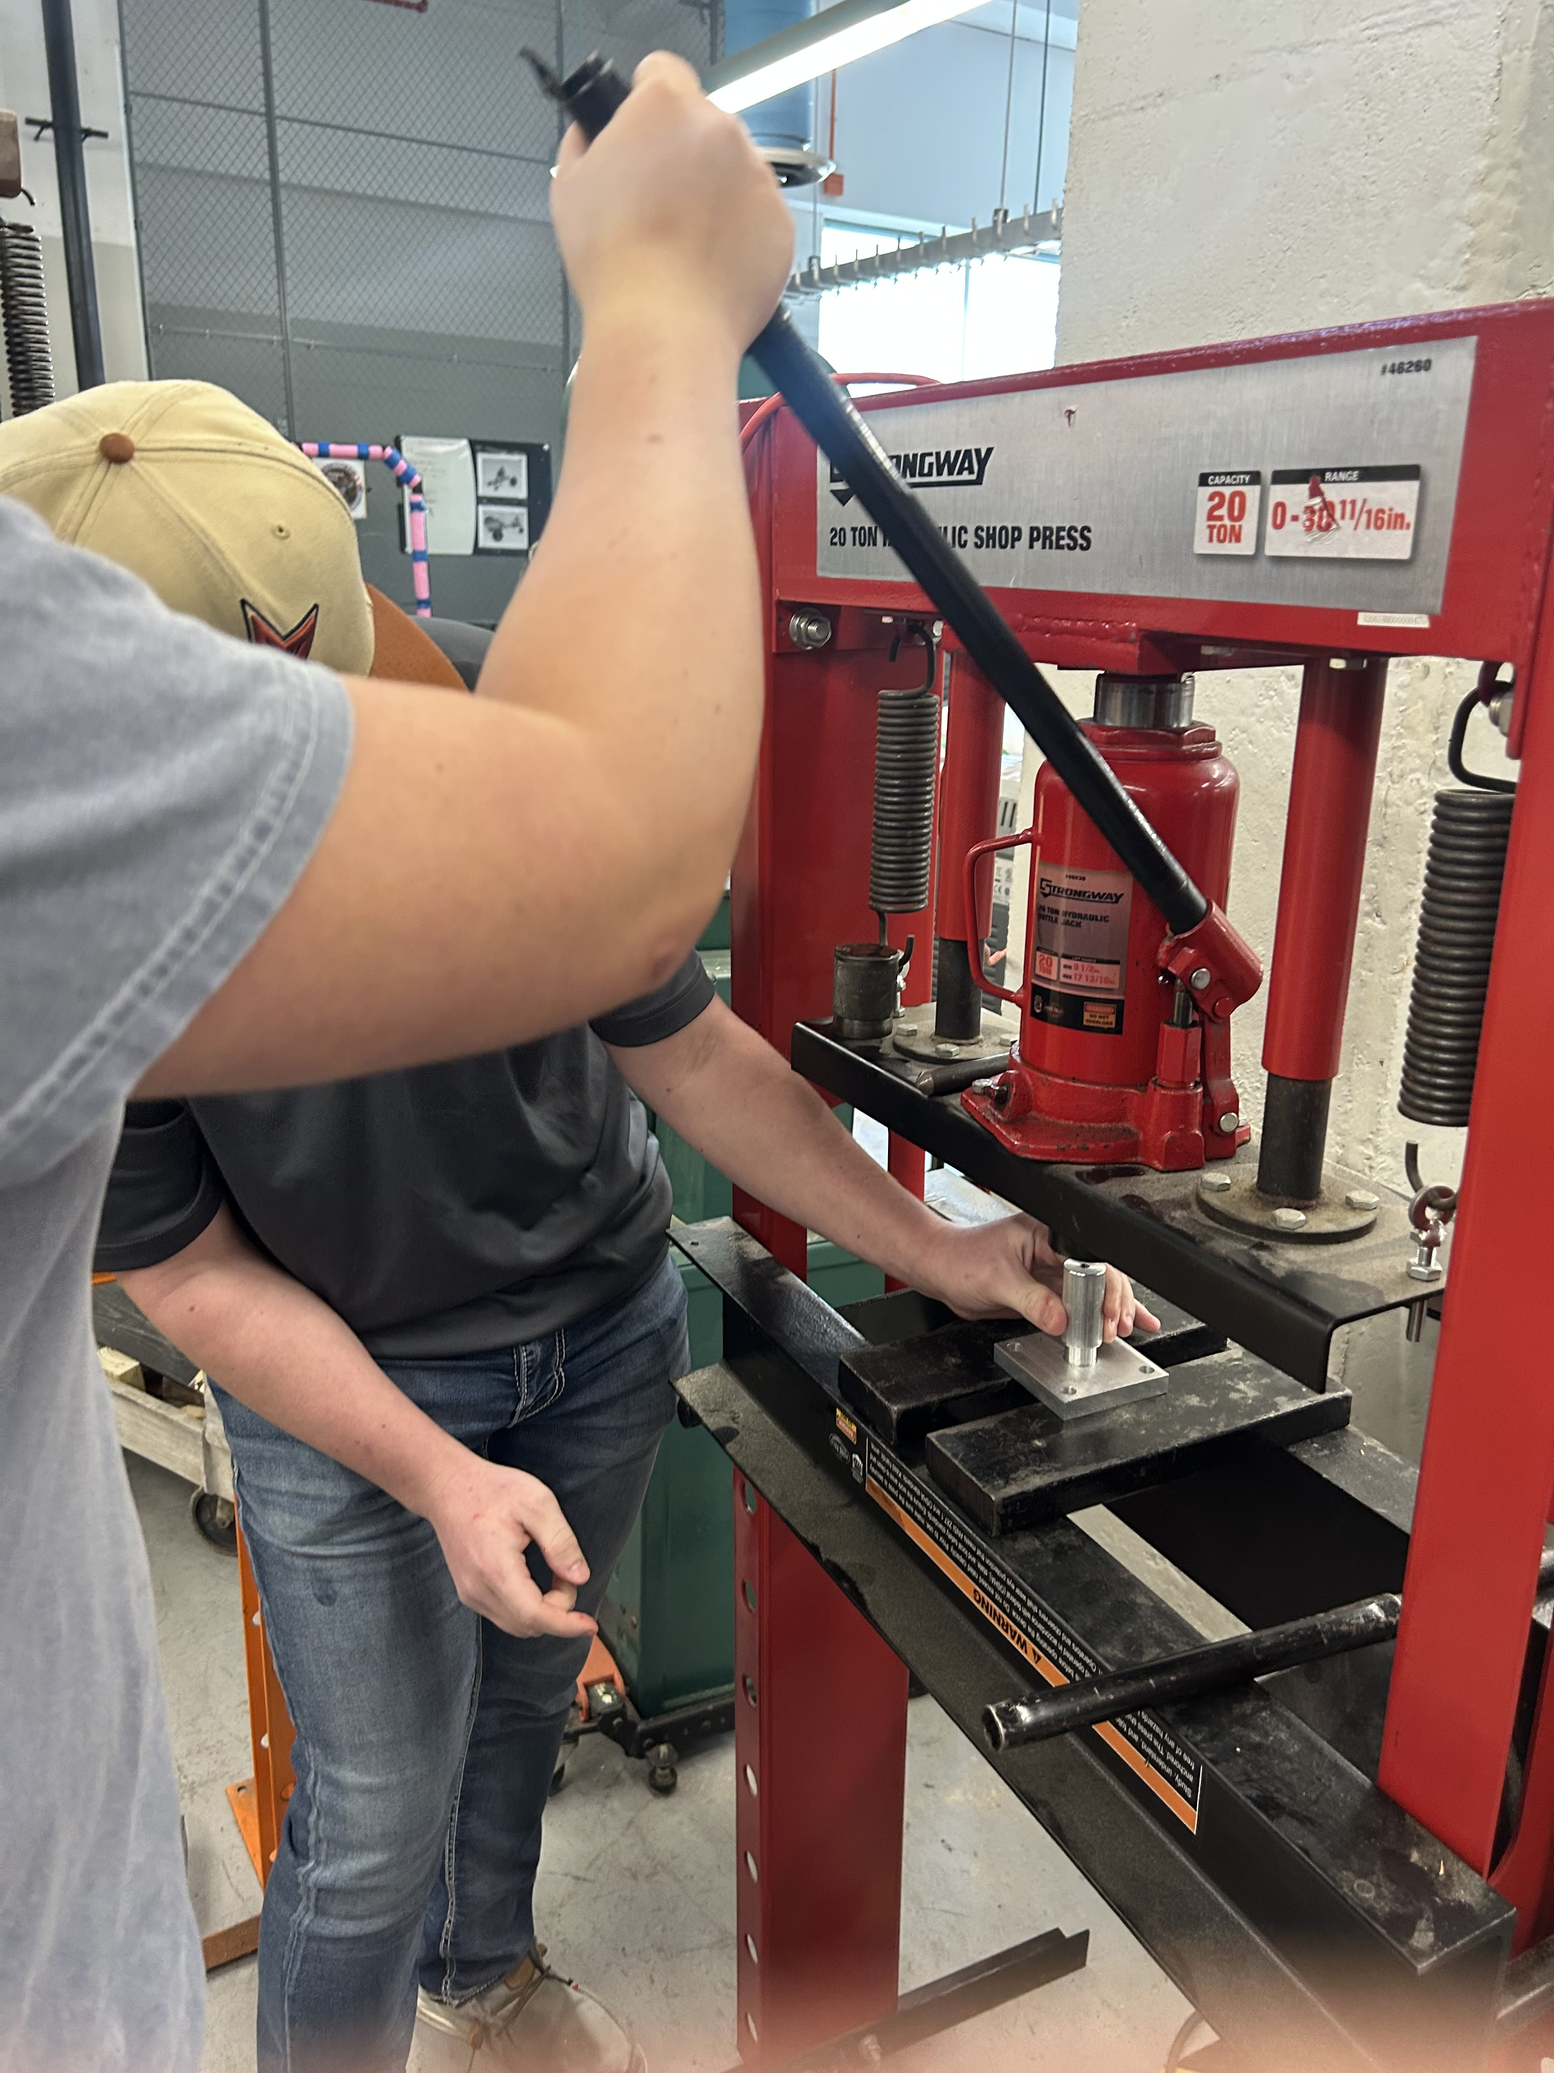Once it was slightly in the flat plate, it went ahead and pumped the hydraulic press until the round bar was flush against the flat plate.

**Figure 18:** Shaft being pressed into plate

**Cutting Notch:**

1. The end mill was removed and replaced with a collet and end mill.
2. The assembly was placed on milling machine vise with shaft parallel with y-axis. (Figure 13)
3. Zeroed out both axis for depth and height. The depth of cut was set to 0.156 inches, and the length of cut was set to 0.625 inches.
4. The end mill was moved along the x-axis to cut the notch.

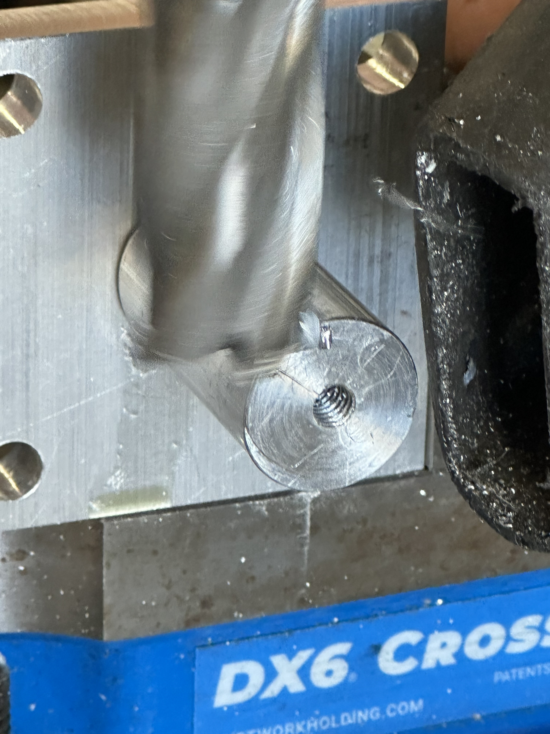

**Figure 19:** Notch being milled

**Data:**

**Table 1:** Measurements for Shaft and Hole diameter.

|  |  |  |  |  |
| --- | --- | --- | --- | --- |
|  | **Average Shaft Diameter (inches)** | **Average Hole Diameter (inches)** | **Interference (inches)** | **Torque (ft-lbf)** |
| **Measured Values** | 0.7536 | 0.7524 | .0012 | N/A |

An average of the Aluminum flat bar center hole diameter and round bar outer diameter was measured. The interference was calculated by adding 0.005 inches to the average hole diameter of 0.754 inches. The torque was converted from kgm to lbf  using the following conversion factor.

1 kgm = 2.20 lbf

**Sample Calculation:**

**Results:**

**Table 2:** Comparison of Theoretical and Actual Values.

|  |  |  |  |
| --- | --- | --- | --- |
|  | Specification for H7/s6 Interference Fit | | Actual Values |
| Minimum Values | Maximum Values |
| Shaft Diameter, d (in.) | 0.75138 | 0.75189 | 0.7536 |
| Hole Diameter, D (in.) | 0.7500 | 0.75083 | 0.7524 |
| Interference,  (in.) | 0.000551 | 0.00189 | 0.005 |
| Contact Pressure, P (psi) | 3024.62 | 11240.2 | 29,500 |
| Force, F (lbf) | 3562.57 | 13185.70 | 332.0 |
| Torque, T (ft-lbf) | 111.33 | 412.51 | 10.49 |

**Table 3:** Comparison of theoretical maximum contact pressure and Aluminum 6061-T6 yield strength.

|  |  |
| --- | --- |
| Theoretical Maximum Contact Pressure, Pmax (psi) | Yield Strength, Sy (psi) |
| 11,240.2 | 40000 |

**Discussion and Analysis:**

The minimum required interference fit needed to prevent rotation is determined to be that of 55 x10^-5 inches through Poisson's Ratio. The ability to be precise was limited due to outdated machinery used in the lab. These limitations of the machines lead to an average shaft diameter of 0.7537 inches and an average hole diameter of 0.7529 inches. The values collected lead to an interference of 0.0012 inches. Any interference exceeding 0.005 in could have caused press-fit failure. The selected interference produced a secure fit—preventing rotation and avoiding plastic deformation of the assembly. The lab also required calculating the theoretical contact pressure, the material’s yield strength, and the actual contact pressure. The values followed as such: Pmax: 11.240 ksi, Sy: 40.0 ksi and P: 29.5 ksi. Calculations show a clear disparity between theoretical and actual contact pressures—the actual value is over double the theoretical estimate. In order to improve quality, prevent the need to re-do the lab due to mistakes and scoring of material, it is recommended that you machine at a slow pace. When milling and using the lathe you will get a shinier and smoother finish the slower you go.

**Conclusions**

This lab was crucial to the development for engineering students. We were introduced to new machines and skills that are vital for any engineer in the workplace. We practiced patience with having to take a little at a time and explored the importance of accuracy with our measurements. We saw firsthand the importance of thinking through a process, measuring twice, and cutting once. It introduced us to new knowledge that will help us form a solid foundation to continue to grow as engineers.